**Runtime snapshots**

1. Your entire interface at runtime including your save button added on with **Title.**

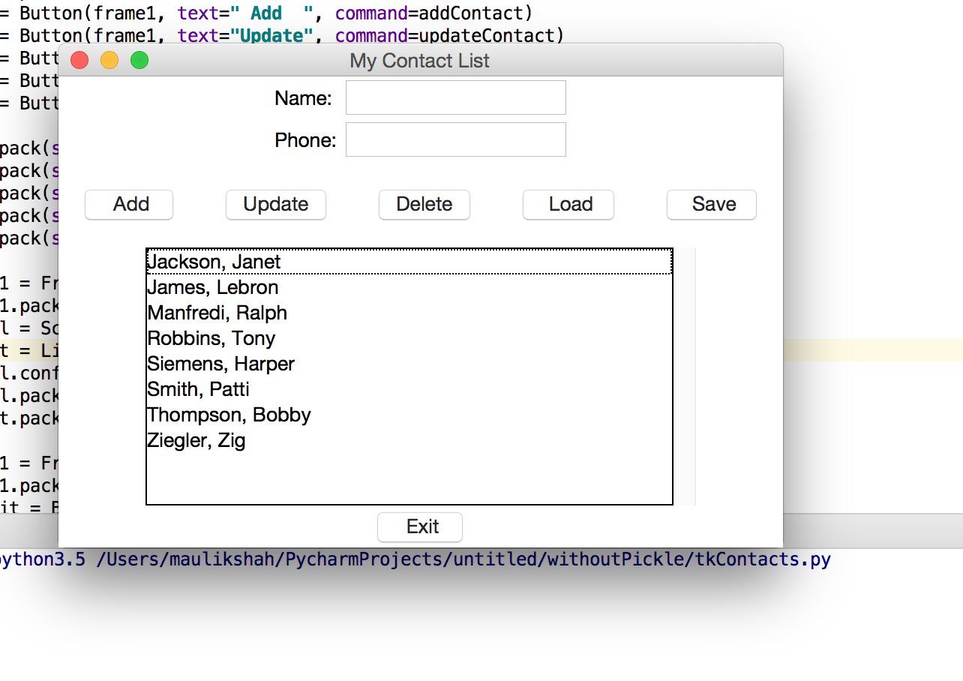

2. Initial snapshot of listbox at runtime

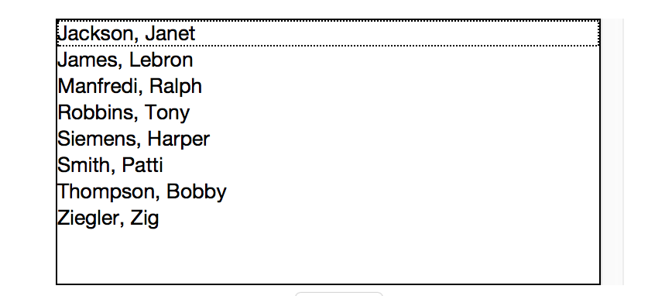

1. Show a contact being added.

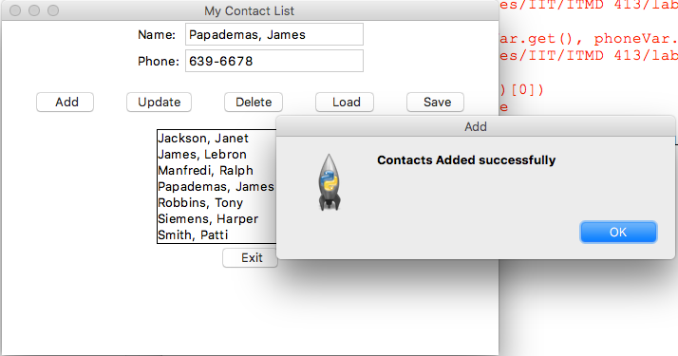

1. Show a contact deleted

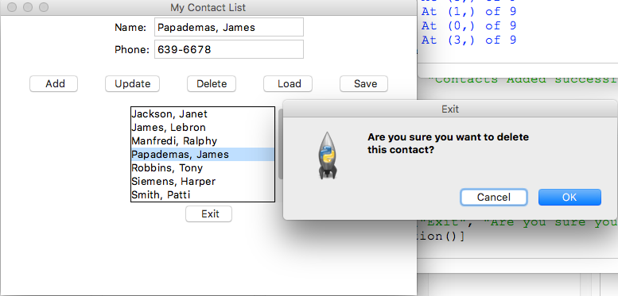

1. Show a contact being updated

After Update ( Entry : Mafredi, Ralph has been updated to Mafredi, Ralphy)

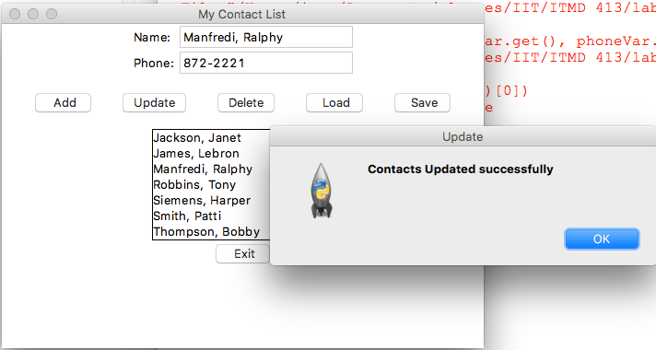

1. Modified contact list from contacts.py

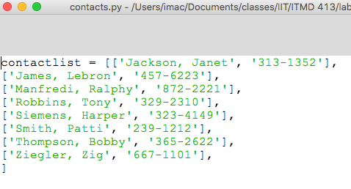

Grad Requirements :

1. Completed message box

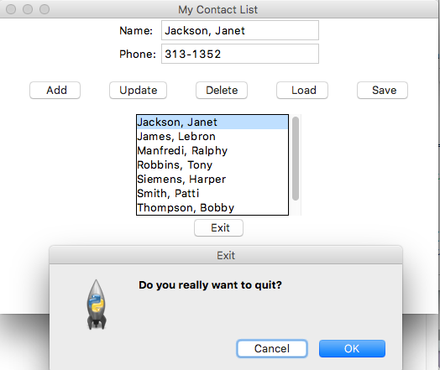

1. GUI with the exit button added in

